Eksamen 22

$$\overline{r}=\left(\begin{aligned}0.3 \\ 0.20 \\ 0.15\end{aligned}\right)$$
$$Σ=\left(\begin{matrix}0.25 & 0.12 & 0.04 \\ 0.12 & 0.16 & 0.05 \\ 0.04 & 0.05 & 0.08\end{matrix}\right)$$
Q1
MVP variance and return
$$w_{mvp}=\frac{1}{a}Σ^{-1}I=\frac{Σ^{-1}I}{I^{T}Σ^{-1}I}$$
$$=\frac{{\left(\begin{matrix}0.25 & 0.12 & 0.04 \\ 0.12 & 0.16 & 0.05 \\ 0.04 & 0.05 & 0.08\end{matrix}\right)}^{-1}\left(\begin{aligned}1 \\ 1 \\ 1\end{aligned}\right)}{transpose\left(\left(\begin{aligned}1 \\ 1 \\ 1\end{aligned}\right)\right){\left(\begin{matrix}0.25 & 0.12 & 0.04 \\ 0.12 & 0.16 & 0.05 \\ 0.04 & 0.05 & 0.08\end{matrix}\right)}^{-1}\left(\begin{aligned}1 \\ 1 \\ 1\end{aligned}\right)}≈\left(\begin{matrix}0,1004367 \\ 0,1353712 \\ 0,7641921\end{matrix}\right)$$
$${\overline{r}}_{mvp}=transpose\left(\left(\begin{aligned}0.3 \\ 0.20 \\ 0.15\end{aligned}\right)\right)\left(\begin{matrix}0,1004367 \\ 0,1353712 \\ 0,7641921\end{matrix}\right)≈0,1718341$$
$$σ_{mvp}^{2}=transpose\left(\left(\begin{matrix}0,1004367 \\ 0,1353712 \\ 0,7641921\end{matrix}\right)\right)\left(\begin{matrix}0.25 & 0.12 & 0.04 \\ 0.12 & 0.16 & 0.05 \\ 0.04 & 0.05 & 0.08\end{matrix}\right)\left(\begin{matrix}0,1004367 \\ 0,1353712 \\ 0,7641921\end{matrix}\right)≈0,0719214$$
Q2
$$w_{tan}=\frac{Σ^{-1}{\overline{r}}_{e}}{I^{T}Σ^{-1}{\overline{r}}_{e}}$$
$$\overline{r_{e}}=\left(\begin{aligned}0.3 \\ 0.20 \\ 0.15\end{aligned}\right)-0.03=\left(\begin{matrix}0,27 \\ 0,17 \\ 0,12\end{matrix}\right)$$
$$w_{tan}=\frac{{\left(\begin{matrix}0.25 & 0.12 & 0.04 \\ 0.12 & 0.16 & 0.05 \\ 0.04 & 0.05 & 0.08\end{matrix}\right)}^{-1}\left(\begin{matrix}0,27 \\ 0,17 \\ 0,12\end{matrix}\right)}{transpose\left(\left(\begin{aligned}1 \\ 1 \\ 1\end{aligned}\right)\right){\left(\begin{matrix}0.25 & 0.12 & 0.04 \\ 0.12 & 0.16 & 0.05 \\ 0.04 & 0.05 & 0.08\end{matrix}\right)}^{-1}\left(\begin{matrix}0,27 \\ 0,17 \\ 0,12\end{matrix}\right)}≈\left(\begin{matrix}0,4436576 \\ 0,046798 \\ 0,5095443\end{matrix}\right)$$
Q3
$${\overline{r}}_{tan}=transpose\left(\left(\begin{aligned}0.3 \\ 0.20 \\ 0.15\end{aligned}\right)\right)\left(\begin{matrix}0,4436576 \\ 0,046798 \\ 0,5095443\end{matrix}\right)≈0,2188885$$
$$σ_{tan}^{2}=transpose\left(\left(\begin{matrix}0,4436576 \\ 0,046798 \\ 0,5095443\end{matrix}\right)\right)\left(\begin{matrix}0.25 & 0.12 & 0.04 \\ 0.12 & 0.16 & 0.05 \\ 0.04 & 0.05 & 0.08\end{matrix}\right)\left(\begin{matrix}0,4436576 \\ 0,046798 \\ 0,5095443\end{matrix}\right)≈0,0957818$$
$$σ_{tan}=\sqrt{0,0957818}≈0,3094863$$
Q4 any efficient portfolio when we have added the risk free asset is a combination of the tangency portfolio and the risk free asset this implies that the efficient frontier must be the line starting in the risk free asset and going through the tangency portfolio
In math the equation for the efficient frontier is
$$\overline{r_{p}}=r_{f}+\frac{{\overline{r}}_{tan}-r_{f}}{σ_{tan}}·σ_{p}$$
Thus
$$\overline{r_{p}}=0.03+\frac{0,2188885-0.03}{0,3094863}·σ_{p}=0,6103291·σ_{p}+0,03$$
Or roughly
$${\overline{r}}_{p}=0.61·σ_{p}+0.03$$
Q5
In capm EQ the market portfolio is the tangency portfolio
$$w_{m}=w_{tan}=\left(\begin{matrix}0,4436576 \\ 0,046798 \\ 0,5095443\end{matrix}\right)$$
Q6
We can do this simply
$$β=\frac{1}{σ_{m}^{2}}Σw_{m}=\frac{1}{0,0957818}·\left(\begin{matrix}0.25 & 0.12 & 0.04 \\ 0.12 & 0.16 & 0.05 \\ 0.04 & 0.05 & 0.08\end{matrix}\right)·\left(\begin{matrix}0,4436576 \\ 0,046798 \\ 0,5095443\end{matrix}\right)≈\left(\begin{matrix}1,4294149 \\ 0,900002 \\ 0,6352955\end{matrix}\right)$$
Q7
In capm
$$V\left(r_{p}\right)=β_{p}^{2}V\left(r_{m}\right)+V(ϵ_{p})$$
Where $V(ϵ_{p})$ is the unsystematic risk that we can get rid of with diversification and still have the same expected return
Asset 1
Systematic:
$${1,4294149}^{2}·σ_{m}^{2}=2,043227·0,0957818≈0,195704$$
Unsystematic
$$0.25-0,195704≈0,054296$$
Asset 2
systematic
$${0,900002}^{2}·0,0957818≈0,0775836$$
Unsystematic
$$0.16-0,0775836=0,0824164$$
Asset 3
Systematic
$${0,6352955}^{2}·0,0957818≈0,0386576$$
Unsystematic
$$0.08-0,0386576=0,0413424$$

Exercise 2
Q1
By standard pricing of fixed cashflows we get
$$P=\left(\begin{aligned}100.9615 \\ 98.1139 \\ 85.4804\end{aligned}\right)$$
$$\frac{105}{1+x}=100.9615$$
$⇕$ Ligningen løses for x vha. WordMat.
$$x=0,0400004$$
$$\frac{3}{1.04}+\frac{103}{{\left(1+x\right)}^{2}}=98.1139$$
$⇕$
$$x=0,04$$

Thus $s_{1}=s_{2}=0.04$
For s_4
$$\frac{100}{{\left(1+x\right)}^{4}}=85.4804$$
$⇕$
$$x=0,0400001$$

Thus we have $s_{1}=s_{2}=s_{4}=0.04$
Q2
For C since it’s a ZCB then $s_{4}=λ_{c}$
Since A and B only have payments in periods with $s_{1}=s_{2}=0.04$
$$λ_{A}=λ_{B}=0.04$$

We calculate the modified duration using the formula
$$D_{mod}=-\frac{dP}{dλ}·\frac{1}{P}=\frac{1}{P}·\frac{1}{1+\frac{λ}{m}}\sum_{k=1}^{n}{\frac{t_{k}·x_{k}}{{m·\left(1+\frac{λ}{m}\right)}^{t_{k}}}}$$

A:
$$D_{A}=\frac{1}{100.9615}·\frac{1}{1+0.04}·\frac{105}{1.04}≈0,9615388$$

B:
$$D_{B}=\left(\frac{3}{1.04}+\frac{2·103}{{\left(1.04\right)}^{2}}\right)\frac{1}{98.1139}·\frac{1}{1.04}≈1,8948071$$

C:
$$D_{C}=\frac{1}{85.4804}·\frac{1}{1.04}·\frac{4·100}{{1.04}^{4}}≈3,8461547$$
Q3
Compute the modified duaration
We also simply have a formula for this
$$C=\frac{1}{P}·\frac{d^{2}P}{dλ^{2}}=\frac{1}{P}·\frac{1}{{\left(1+\frac{λ}{m}\right)}^{2}}\sum_{k=1}^{n}{\frac{t_{k}+1}{m}\frac{t_{k}}{m}\frac{x_{k}}{{\left(1+\frac{λ}{m}\right)}^{t_{k}}}}$$
A:
$$C_{A}=\frac{1}{100.9615}·\frac{1}{{\left(1+0.04\right)}^{2}}·\frac{2·105}{1.04}≈1,8491131$$
B
$$C_{B}=\left(\frac{2·3}{1.04}+\frac{3·2·103}{{\left(1.04\right)}^{2}}\right)\frac{1}{98.1139}·\frac{1}{{1.04}^{2}}≈5,4386073$$
C:
$$C_{C}=\frac{1}{85.4804}·\frac{1}{{1.04}^{2}}·\frac{5·4·100}{{1.04}^{4}}≈18,4911284$$
Q4
Yes we can hedge with price moderation and convexity
We call the new bond D
Par price implies $λ_{D}=4\%$
$$D_{D}=\frac{1}{100}·\frac{1}{1.04}·\left(\frac{4}{1.04}+2·\frac{4}{{1.04}^{2}}+3·\frac{104}{{1.04}^{3}}\right)≈2,775091$$
$$C_{D}=\frac{1}{100}·\frac{1}{{1.04}^{2}}·\left(\frac{2·4}{1.04}+3·2·\frac{4}{{1.04}^{2}}+4·3·\frac{104}{{1.04}^{3}}\right)≈10,533923$$
Since we are short this bond we want the price, duration and Convexity to equal these
We set up a system of equations to find the weights needed
$$P_{D}=w_{A}·P_{A}+w_{B}·P_{B}+w_{C}·P_{C}$$
$$P_{D}·D_{D}=w_{A}·P_{A}·D_{A}+w_{B}·P_{B}·D_{B}+w_{C}·P_{C}·D_{C}$$
$$P_{D}·C_{D}=w_{A}·P_{A}·C_{A}+w_{B}·P_{B}·C_{B}+w_{C}·P_{C}·C_{C}$$

$$100=w_{A}·100.9615+w_{B}·98.1139+w_{C}·85.4804$$
$$100·2,775091=w_{A}·100.9615·0,9615388+w_{B}·98.1139·1,8948071+w_{C}·85.4804·3,8461547$$
$$100·10,533923=w_{A}·100.9615·1,8491131+w_{B}·98.1139·5,4386073+w_{C}·85.4804·18,4911284$$
$⇕$ Ligningssystemet løses for w_A,w_B,w_C vha. WordMat's 'Løs Ligninger' funktion,
$$w_{A}=-0,2960039 ∧ w_{B}=1,0097088 ∧ w_{C}=0,3605333$$

Q5
We calculate the position in terms of cash flows since they all have the same yield
$$B=\left(\begin{matrix}1,0097088·3-4-0,2960039·105 & 1,0097088·103-4 & -104 & 0,3605333·100\end{matrix}\right)=\left(\begin{matrix}-32,0512831 & 100,0000064 & -104 & 36,05333\end{matrix}\right)$$

The price of this now should be 0 thus we should have
$$\left(\begin{matrix}-32,0512831 & 100,0000064 & -104 & 36,05333\end{matrix}\right)\left(\begin{aligned}\frac{1}{1.04} \\ \frac{1}{{1.04}^{2}} \\ \frac{1}{{1.04}^{3}} \\ \frac{1}{{1.04}^{4}}\end{aligned}\right)≈2,1·{10}^{-6}$$
The price of the position after the shift in yield
$$\left(\begin{matrix}-32,0512831 & 100,0000064 & -104 & 36,05333\end{matrix}\right)\left(\begin{aligned}\frac{1}{1.05} \\ \frac{1}{{1.05}^{2}} \\ \frac{1}{{1.05}^{3}} \\ \frac{1}{{1.05}^{4}}\end{aligned}\right)≈-2,43·{10}^{-5}$$
Meaning that after the small yield shift we’ve lost a very small amount meaning that our hedge was a good one
Q6

$$B=\left(\begin{matrix}105 & 0 & 0 & 0 \\ 3 & 103 & 0 & 0 \\ 0 & 0 & 0 & 100 \\ 4 & 4 & 104 & 0\end{matrix}\right)$$
$$P=\left(\begin{aligned}100.9615 \\ 98.1139 \\ 85.4804 \\ 100\end{aligned}\right)$$
$$d={\left(\begin{matrix}105 & 0 & 0 & 0 \\ 3 & 103 & 0 & 0 \\ 0 & 0 & 0 & 100 \\ 4 & 4 & 104 & 0\end{matrix}\right)}^{-1}\left(\begin{aligned}100.9615 \\ 98.1139 \\ 85.4804 \\ 100\end{aligned}\right)≈\left(\begin{matrix}0,9615381 \\ 0,9245562 \\ 0,8889964 \\ 0,854804\end{matrix}\right)$$
The bond
$$B^{'}=\left(\begin{matrix}50 & 50 & 50 & 50\end{matrix}\right)$$
$$P^{'}=\left(\begin{matrix}50 & 50 & 50 & 50\end{matrix}\right)\left(\begin{matrix}0,9615381 \\ 0,9245562 \\ 0,8889964 \\ 0,854804\end{matrix}\right)=181,494735$$
Q7
The price is to high there is arbitrage we recreate the bond in the market buy that recreation and sell the bond gaining $183.25-181,494735≈1,755265$ with no obligations in the future
The replication portfolio we can calculate
$$\left(\begin{matrix}50 & 50 & 50 & 50\end{matrix}\right){\left(\begin{matrix}105 & 0 & 0 & 0 \\ 3 & 103 & 0 & 0 \\ 0 & 0 & 0 & 100 \\ 4 & 4 & 104 & 0\end{matrix}\right)}^{-1}=\left(\begin{matrix}\frac{12500}{28119} & \frac{625}{1339} & \frac{1}{2} & \frac{25}{52}\end{matrix}\right)≈\left(\begin{matrix}0,4445393 & 0,4667662 & 0,5 & 0,4807692\end{matrix}\right)$$
We buy basically half of each bond and sell the annuity to gain a profit

Exercise 3
Q1
We note that the tree is recombining and that $s_{ud}=s_{0}$
We note that $u=1.2 ,d=\frac{1}{1.2}=0.833…$throughout the tree
Also the atm options both only pay out in the respective “upup” and “downdown” states
Thus
There are many ways
$$c_{0}=\frac{1}{{\left(1+r\right)}^{2}}·q^{2}·c_{uu}$$
$$p_{0}=\frac{1}{{\left(1+r\right)}^{2}}·{\left(1-q\right)}^{2}·p_{dd}$$
We actually only need 1
$$32.4198=\frac{1}{{\left(1+r\right)}^{2}}·{\left(\frac{1+r-\frac{1}{1.2}}{1.2-\frac{1}{1.2}}\right)}^{2}·(325.44-226)$$
$⇕$ Ligningen løses for r vha. WordMat.
$$r=0,0539999$$
Since $1.054∈(0.833,1.2)$ the model is arbitragefree and complete

Q2
Since no dividends and positive interestrate then
$$C_{E}=C_{A}=32.4198$$
For the put we actually need to price it
We find the value of exercising, by looking at the tree we note that there is only positive intrinsic value in “down” and “downdown”
$$P_{dd}=226-156.94=69,06$$
$$P_{d}^{E}=226-188.33≈37,67$$
Here the E is for exercisevalue

Now I notice I havent actually calculated the risk neutral probabilities and do so
$$q=\frac{1+0.054-\frac{1}{1.2}}{1.2-\frac{1}{1.2}}≈0,6018182$$
We see that if we go up from 0 we never exercise and thus
$$P_{u}=0$$
$$P_{d}=\max{\{P_{d}^{E},\frac{1}{1+r}·(q·P_{du}+\left(1-q\right)·P_{dd})}$$
The second term equals
$$\frac{1}{1.054}·\left(1-0,6018182\right)·69,06≈26,0895969<37,67$$
Thus we exrcise in the down state
Sine we are at the money
$$P_{0}^{e}=0$$
$$P_{0}=\frac{1}{1.054}·\left(1-0,6018182\right)·37,67≈14,2310326$$

Q3
We note the payout of this derivative at time T
$$f_{uu}=\sqrt{325.44}≈18,0399557$$
$$f_{ud}=\sqrt{226}=\sqrt{226}≈15,0332964$$
$$f_{dd}=\sqrt{156.94}≈12,5275696$$
$$f_{0}=\frac{1}{{1.054}^{2}}·\left({0,6018182}^{2}·18,0399557+2·15,0332964·0,6018182·\left(1-0,6018182\right)+{\left(1-0,6018182\right)}^{2}·12,5275696\right)≈14,1549711$$
Q4
We simply have a fomula for this
$$X=n·\frac{S\left(0\right)}{\sum_{i=1}^{n}{d_{0,i}}}$$
$$=2·\frac{226}{\frac{1}{1.054}+\frac{1}{{1.054}^{2}}}≈244,4664226$$
Assuming we are simply to write up the payment from fixed to nonfixed leg in each state
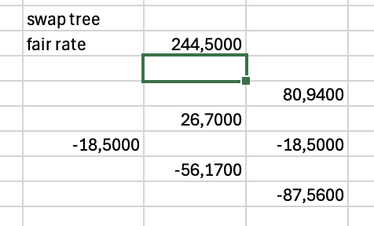

Q5
$$1.2=e^{σ}$$
$⇕$ Ligningen løses for σ vha. WordMat.
$$σ=0,1823216$$
S=K=226
Callprice:
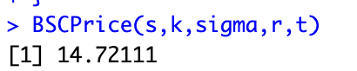
Put price
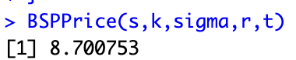
Q6
One way to hedge some of their risk would be to buy puts or sell calls until the portfolio is delta neutral
The 100 S will have 100$Δ$
If using selling calls we find the delta of the call
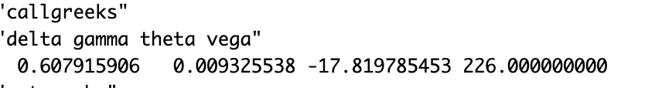
Note that the delta of the call is roughly 0.6 so we would need to sell $\frac{100}{0.6}≈166,6666667$
Calls this would make our strategy “delta neutral” midigating some of our short tem risk a thing to note is that this would make us long time and short vol

Exercise 4
Q1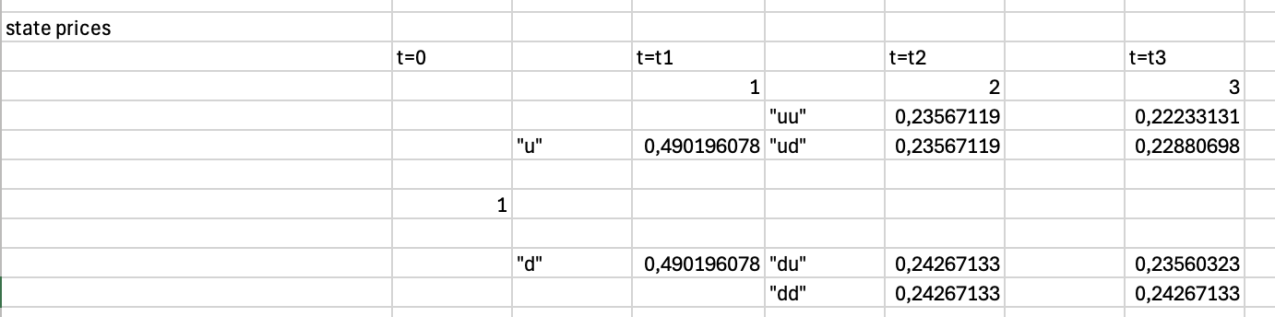
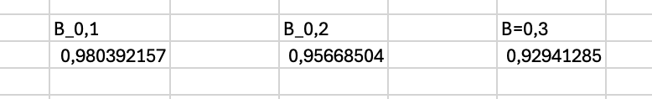
Q2
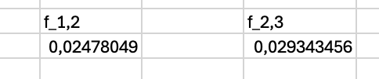
$$f_{0,1}=s_{1}=0.02$$

Q3
The only thing we are actually trading at that time is the payment of 107 at time 3
The price of that payment today is
$$107·B_{0,3}=107·0.92941≈99,44687$$
Im assuming we are to find the forwardprice
To find the fair forwardprice we must have
$$E\left[F_{2}·d_{0,2}-107·d_{0,3}\right]=0$$
$$⇔F_{2}=107·\frac{B_{0,3}}{B_{0,2}}=107·\frac{0.92941}{0.956685}≈103,94944$$

Q4
We find the actual fair interestswap rate
$$c=\frac{\left(1-B_{0,3}\right)}{B_{0,1}+B_{0,2}+B_{0,3}}=\frac{1-0.92941}{0.92941+0.956685+0.98039}≈0,024626$$
I want to hold the fixed end im not sure if that means buying or selling the swap anyway I want to have the fixed rate since its priced to high

Q5 the insurance only pay out in the “upup” state
We calculated the stateprices when finding the ZCB prices
In the upup world it pays out 1% of his 100000
$$100000·0.01=1000$$
$$P_{insurance}=1000·0.23567=235,67$$
Q5
uing itos lemma
$$a\left(x,t\right)=x·t·e^{-λ·t}$$
$$b\left(x,t\right)=σ·x·e^{-λ·t}$$
$$r_{t}=f\left(x,t\right)=x_{t}^{2}$$
Ive not written the subscipts for convinience
$$d f\left(t,X\left(t\right)\right)=\left\{\frac{∂f}{∂t}\left(t,x\left(t\right)\right)+a\left(t,X\left(t\right)\right)\frac{∂f}{∂x}\left(t,X\left(t\right)\right)+\frac{1}{2}b\left(t,X\left(t\right)\right)^2 ·\frac{∂^{2}f}{∂x^{2}}\left(t,X\left(t\right)\right)\right\}dt+b\left(t,X\left(t\right)\right)·\frac{∂f}{∂x}\left(t,X\left(t\right)\right) dW_{t}$$

$$\frac{∂f}{∂x}=2x$$
$$\frac{∂^{2}f}{∂x^{2}}=2$$
$$\frac{∂f}{∂t}=0$$
$$d r_{t}=\left\{0+x·t·e^{-λ·t}2x+\frac{1}{2}σ^{2}·x^{2}·e^{-2λ·t} ·2\right\}dt+σ·x·e^{-λ·t}·2·x dW_{t}$$
$$=\left(2·r_{t}·t·e^{-λt}+σ^{2}·r_{t}·e^{-2λ·t}\right)dt+2·σ·r_{t}·e^{-λt}dW_{t}$$

